**Topic: Variables and data Type in Java**

**Variables:**

**A variable is a placeholder that stores a value. This value can be changes during the execution of the program.**

**Example:**

**int number = 8; value it stores**

**Data type variable name**

**Rules for declaring a variable name:**

**We can choose a name while declaring a java variable if the following rules are followed**:

1. **Must not begin with a digit**
2. **Name is case sensitive.**
3. **Should not be a keyword.**
4. **White space not allowed.**
5. **Can contain alphabets, $character, __character and digits if the other conditions are met.**

**Data Types:**

Primitive data types:

Java is statically typed.

There are 8 primitive data types supported by java.

1. **Byte**:

* Value range from -128 to 127
* Takes 1 byte
* Default value is 0

1. **Short:**

* Take 2 byte
* Default value is 0.

1. **int:**

* takes 4 byte
* default value is 0

1. **float:**

* take 4 byte
* default value is 0.0f

1. **long:**

* take 8 byte
* default value is 0

1. **double:**

* take 8 byte
* default value is 0.0d

1. **char**

* take 2 byte
* default value is ‘\00000’

1. **Boolean**

* Take 16 byte
* Default value is false

**Example:**

Bool a = 0;

Bool b = 1;

0= off = false

1= on= true

1. **String:**

* Dependent
* Null (because it is an object not a primitive type)

**Note:**

*The size of a string depends on content stored in it, so there is no default size.*

* String is basically an array or collection of data.

**For example:**

If we store like:

int semester = 2;

If I write int semester = 2;, it will take 4 bytes. So isn’t better to use byte, which takes only 1 byte.

**Example:**

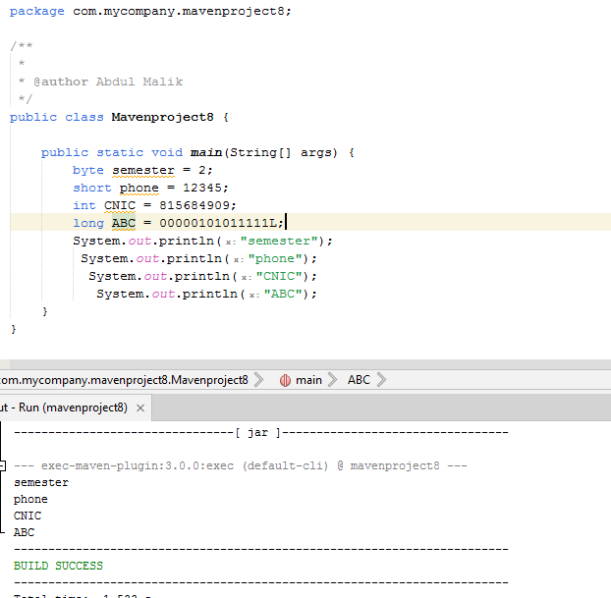

**Type casting:**

The process of converting data type of a value during execution.

**Implicit type casting:**

* Convert a small data type to a larger data type.
* No data loss occurs
* Done automatically by the complier.

**Order:**

**Byte short int long float double**

**Explicit type casting:**

* Convert a larger data type to a smaller data type
* Data loss is possible
* Needs manual casting using parentheses ().

**Reason:**

**Implicit**: no risk, automatic, no data loss.

**Explicit**: risk of data loss, needs manual casting.

**The end.**